30.73: a) Just after the switch is closed there is no current in the inductors. There is no current in the resistors so there is no voltage drop across either resistor. A reads zero and  reads 20.0 V.
b) After a long time the currents are no longer changing, there is no voltage across the inductors, and the inductors can be replaced by short-circuits. The circuit becomes equivalent to

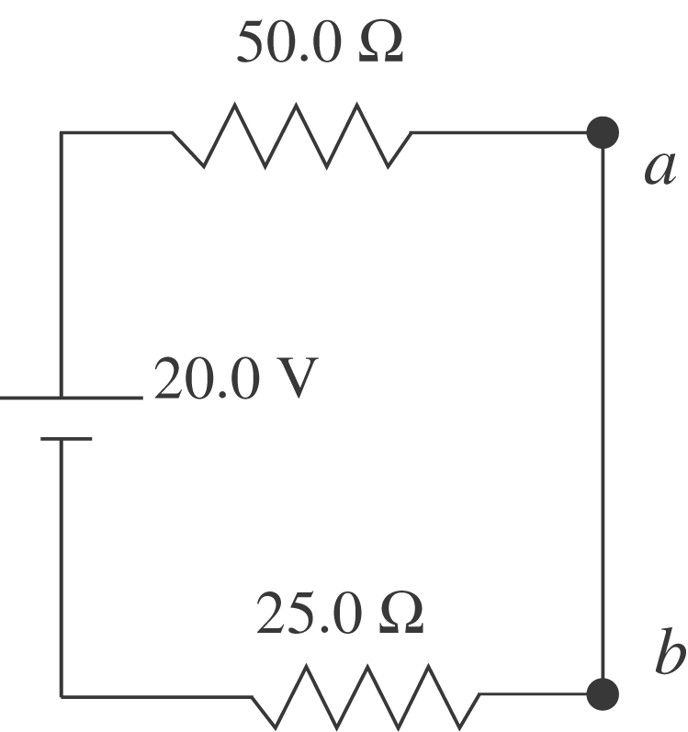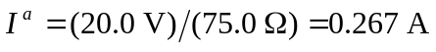

The voltage between points and is zero, so the voltmeter reads zero.
c) Use the results of problem 30.49 to combine the inductor network into its equivalent:
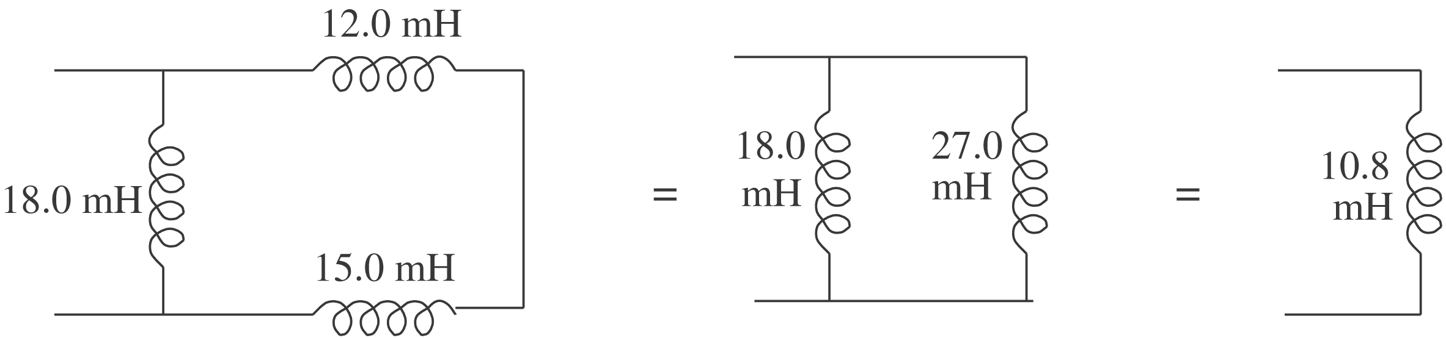

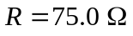 is the equivalent resistance.
